Installing Cluster624 node

# Install VirtualBox

<https://virtualbox.org>

# Import virtual machine image

\\EPBYMINW1909\Share\node-template.ova

Check ‘Reinitialize MAC addresses’!

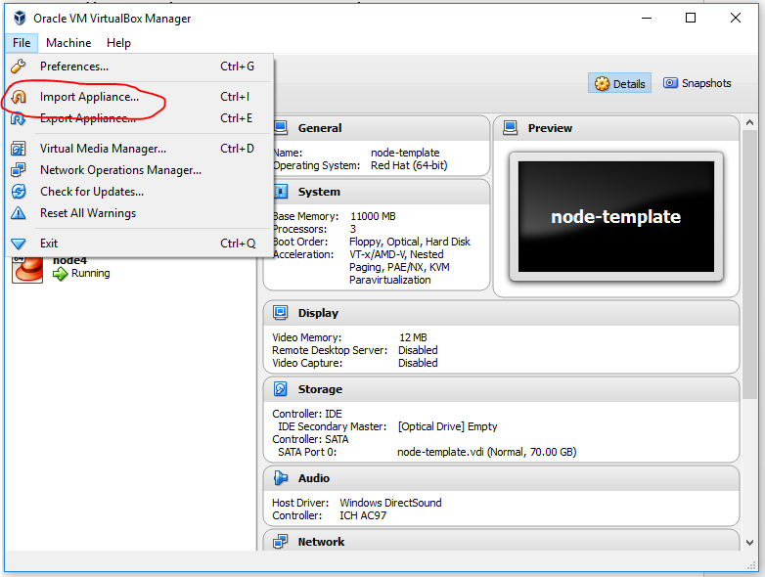

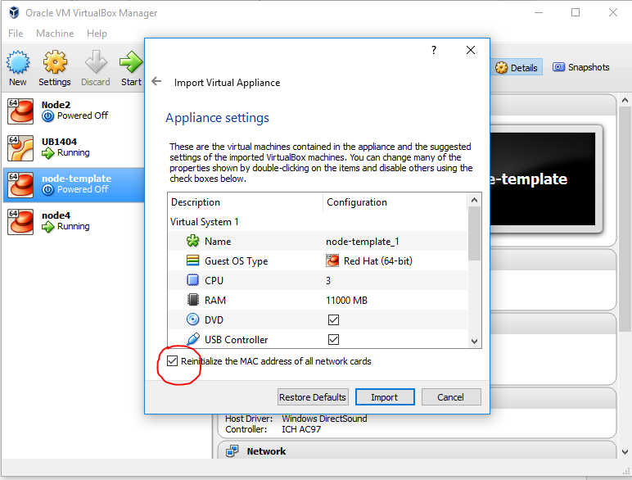

# Run and login to VM

Login: root

Password: Hadoop

# Set ID of node

cd

./node_set_id.sh X #X is new node ID (number)

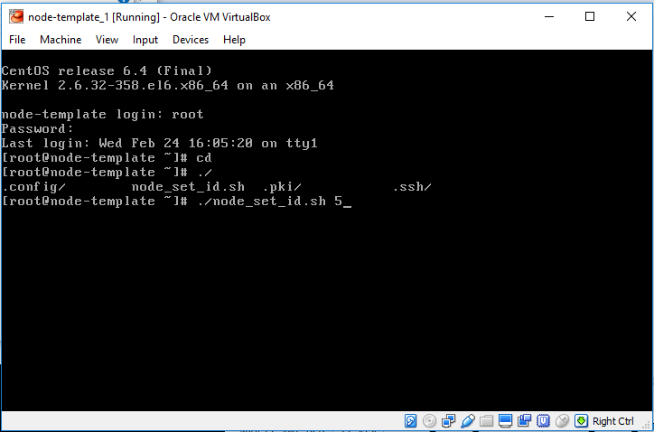

# Reboot VM

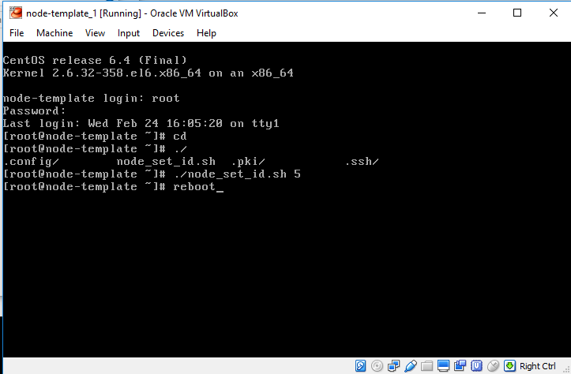

# Set it to autorun

Get vbox_autostart.bat script and set VM’s name in it.

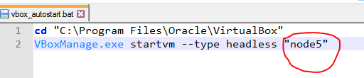

Create shortcut to vbox_autostart.sh in Startup folder of Windows